**User Guide**

**Step 1 : Open the command prompt**

**Step 1.1 : Type the four commands given below in the screenshot.**

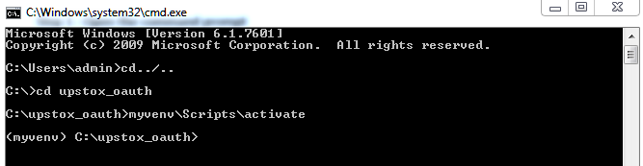

**For second algo , the location is :**

**Open another cmd and go to folder “upstox_oauth_next40”**

**<myvenv> C:\upstox_oauth_next40>**

**Step 2 : By executing this command (Step 1.1) you will get below given response :**

**python manage runserver**

**For second , python manage runserver 8100**

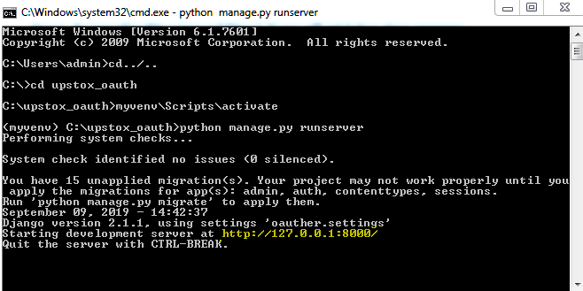

**Copy the url “http://127.0.0.1:8000/” into your Google Chrome Browser.**

**And for second Algo, Copy the url “http://127.0.0.1:8100/” into your Google Chrome Browser.**

**After executing http://127.0.0.1:8000/ , The below screen will come up.**

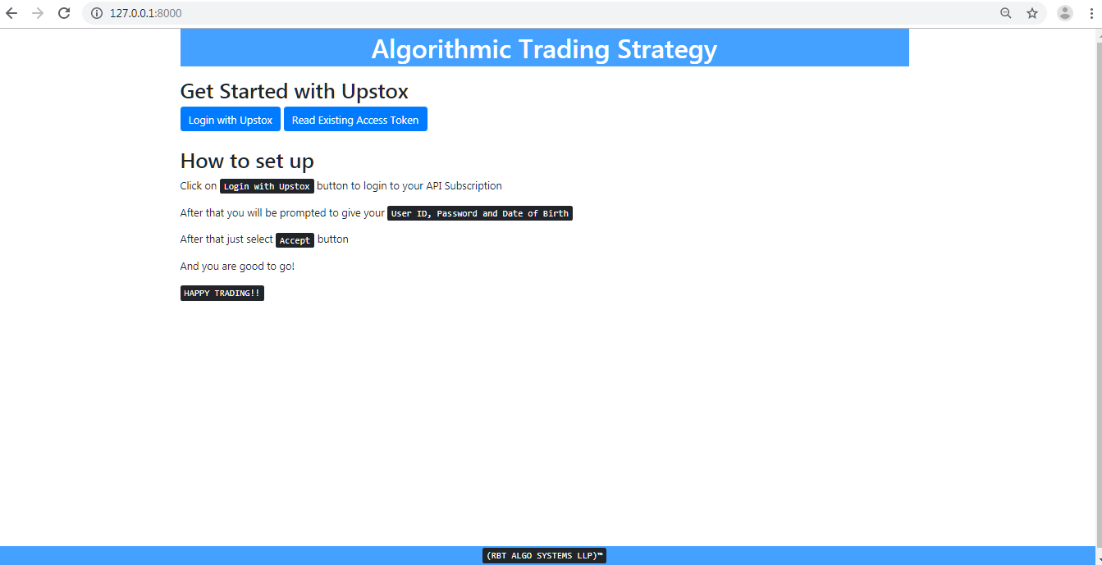

**Step 3 : Click on “Login with Upstox” button, you will get below screen where you will be asked to give User ID, Password and Year of Birth and then click on “LOG IN” button.**

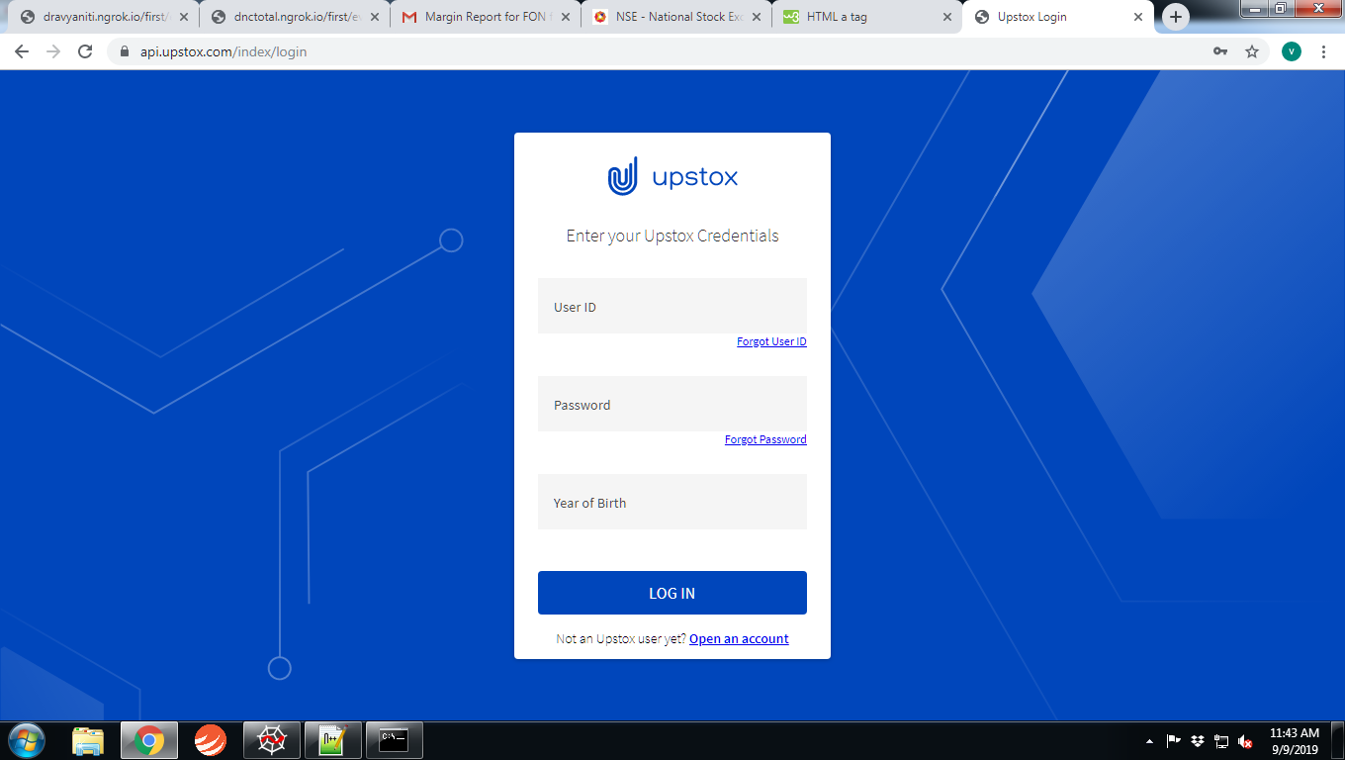

**Step 4: After clicking on “LOG IN” button, you will get below screen. You have to click on “ACCEPT” button.**

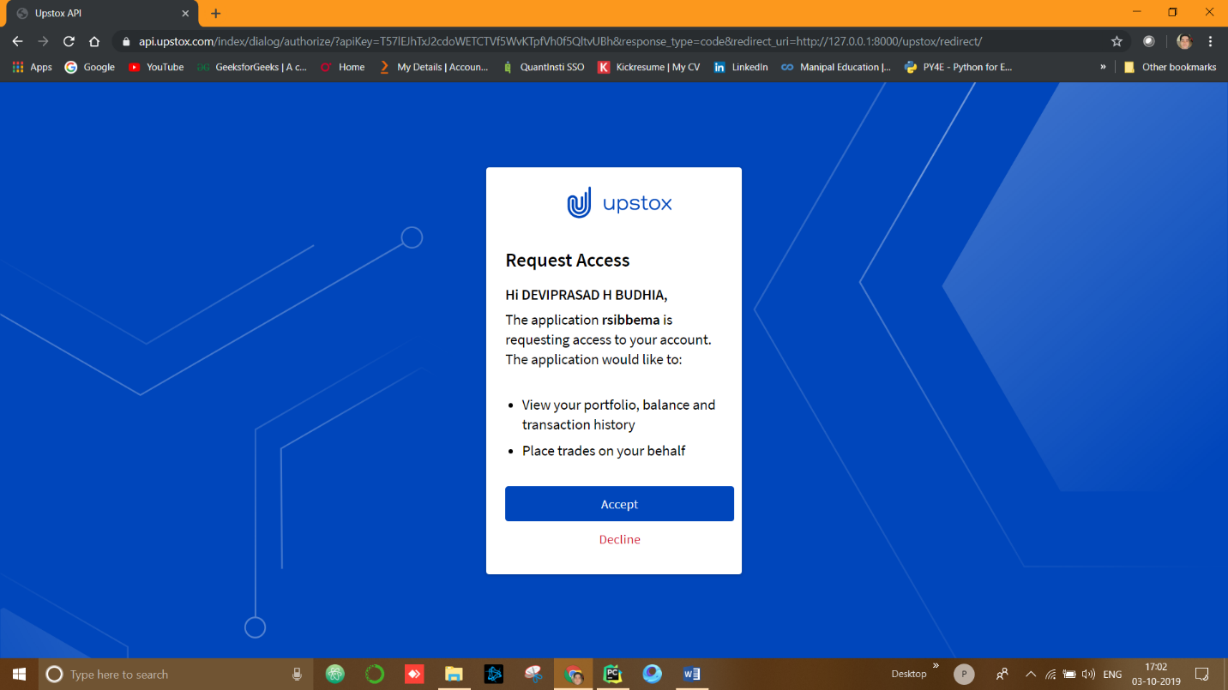

**After clicking on “ACCEPT” button you will get below screen.**

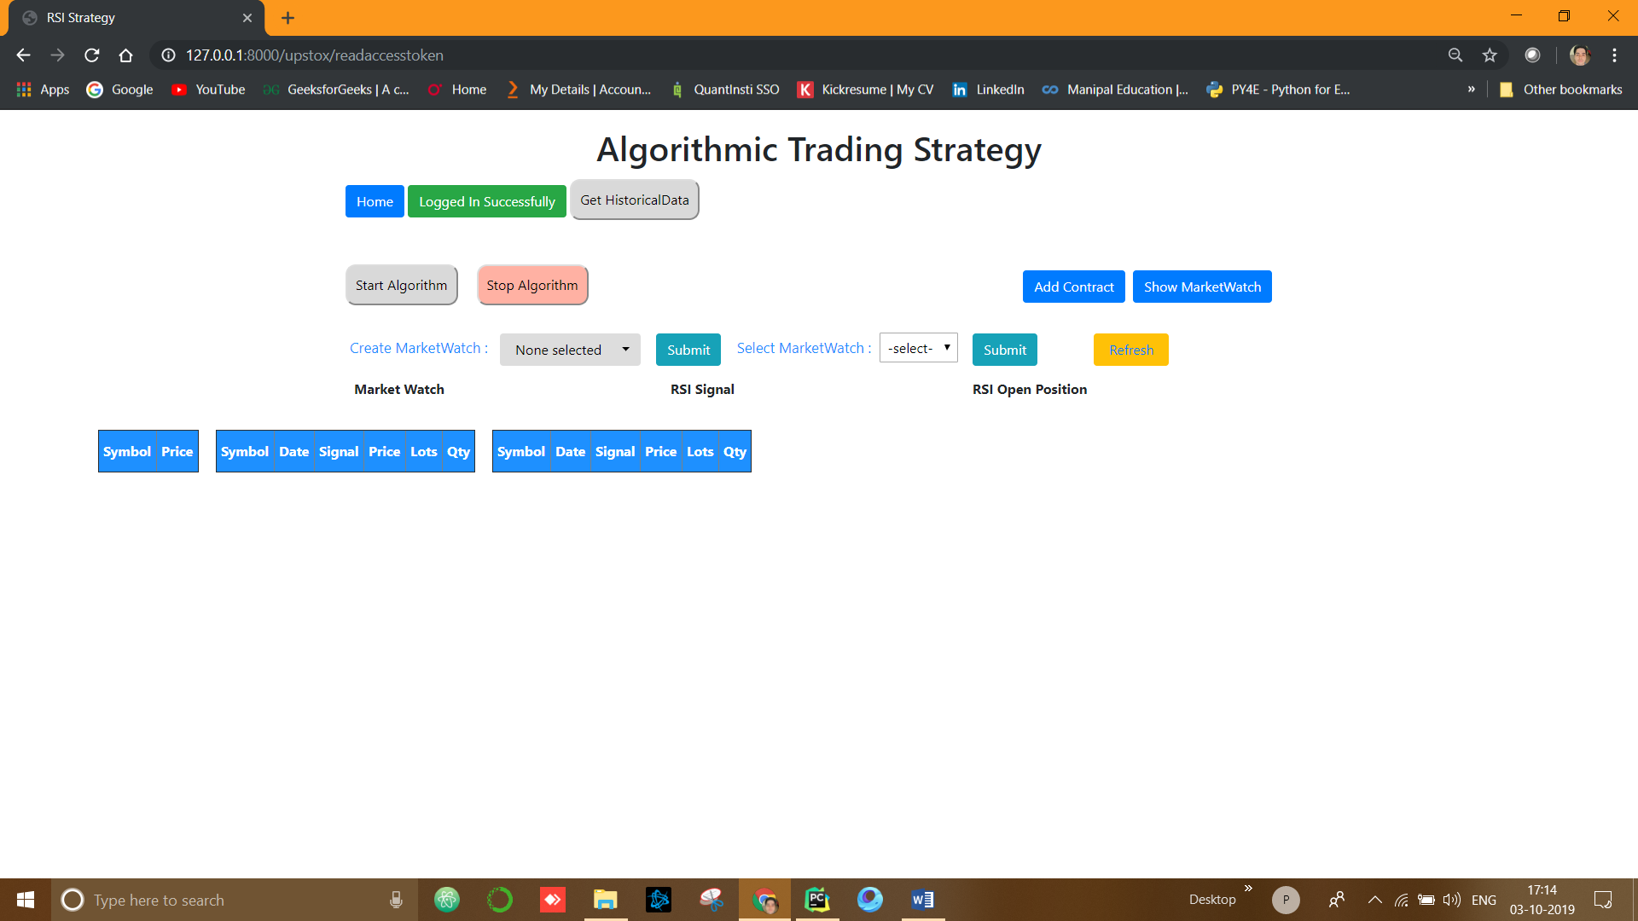

**Step 5: Click on “Add Contract” button, to add the contract for particular exchange. Here you will be asked to input following fields:**

**Contract, Exchange, Timeframe, Number of Lot and Quantity per Lot.**

**After that click on “Submit” button. Keep on repeating same process for multiple contracts.**

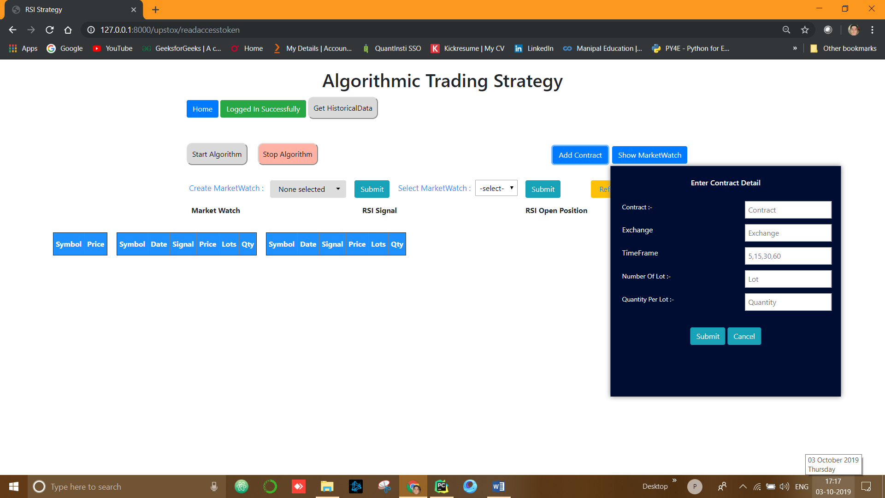

**After executing step 5 click on “Refresh” button.**

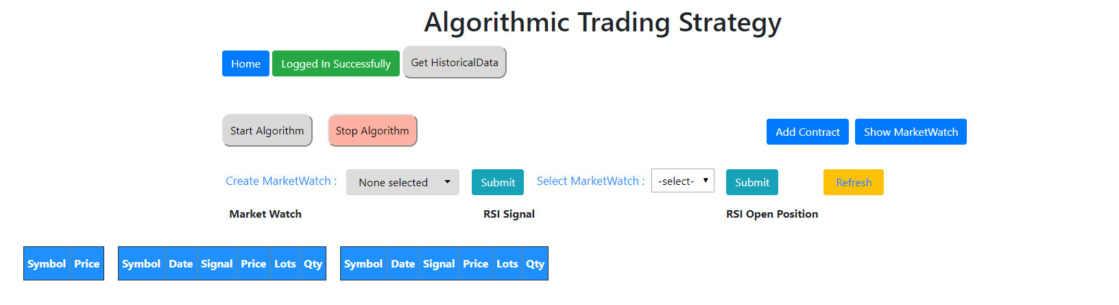

**After clicking on “Refresh” button, you can see the added contract in the “Create Marketwatch” dropdown.**

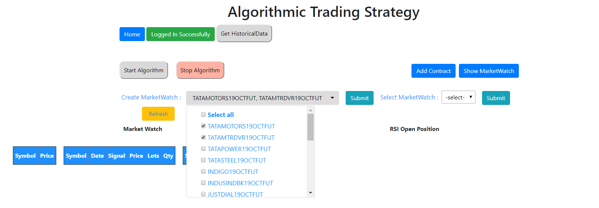

**STEP 6 : Select both the contract from dropdown checkbox and then click “Submit” button. After click on “Submit” button you will be asked to enter the name for your “MarketWatch”. (Don’t forget to click on “Refresh ” button after that)**

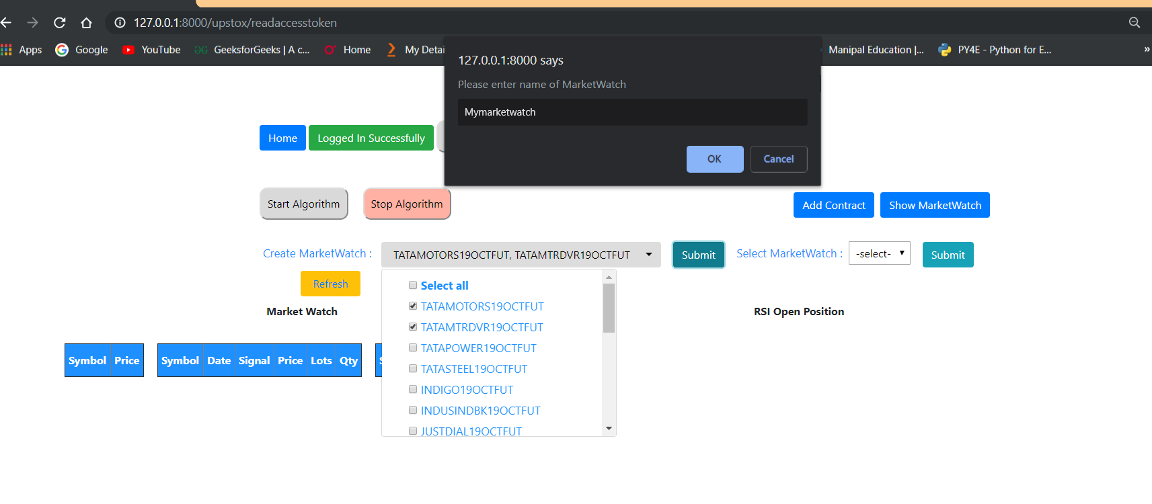

**After that you will be able to see your market watch in the “Select MarketWatch” dropdown.**

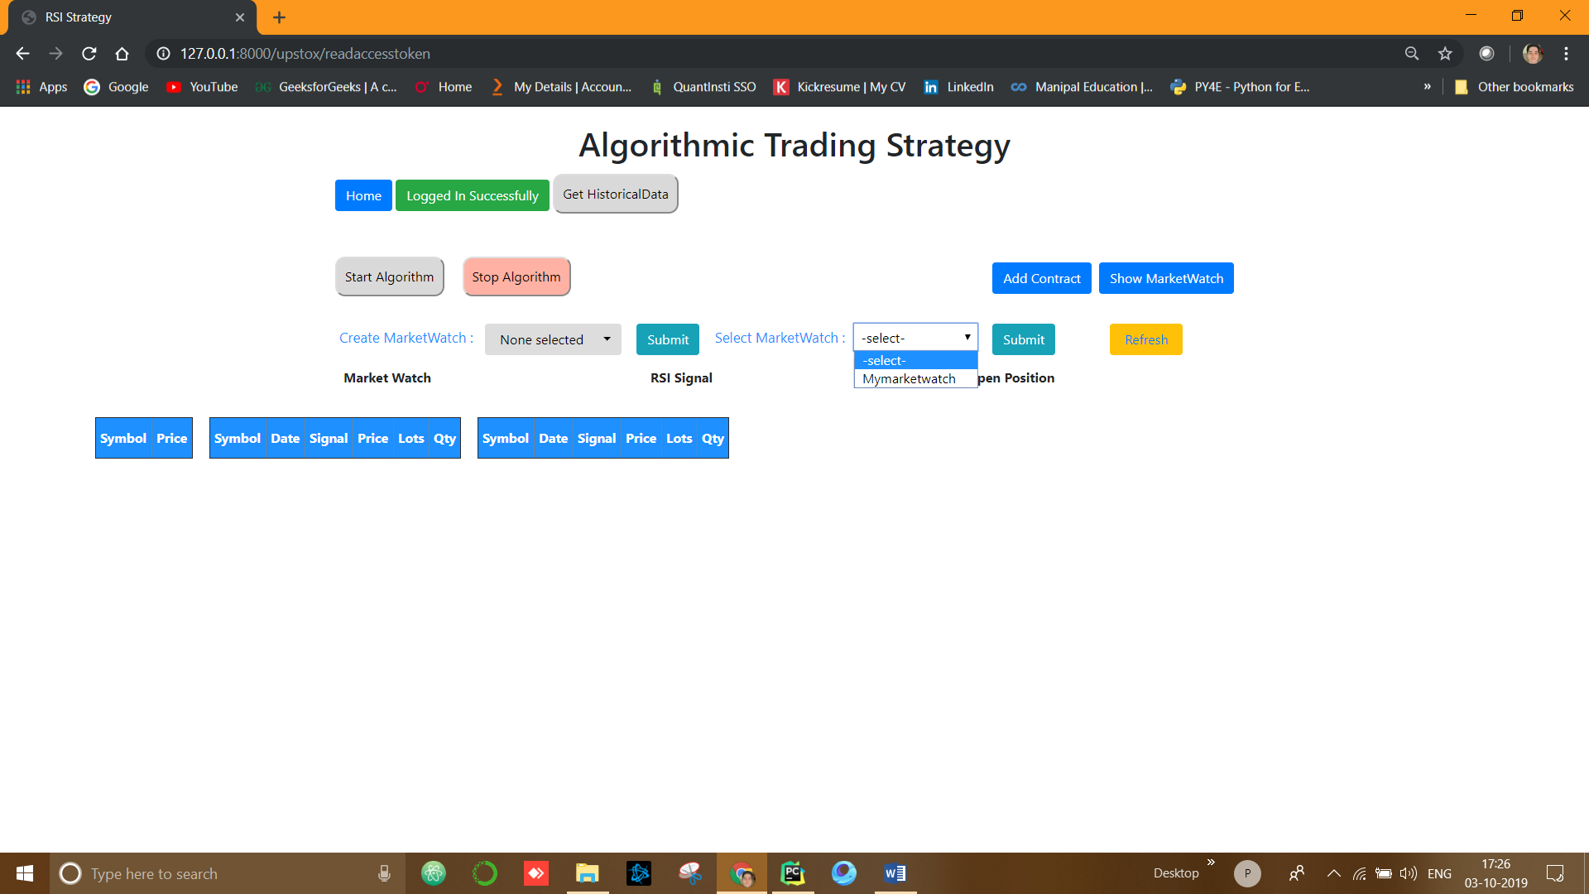

**STEP 7: Select your market watch from the dropdown and then click on “Submit” button. After clicking on “Submit” button you will see your market watch as a table on the left-side corner.**

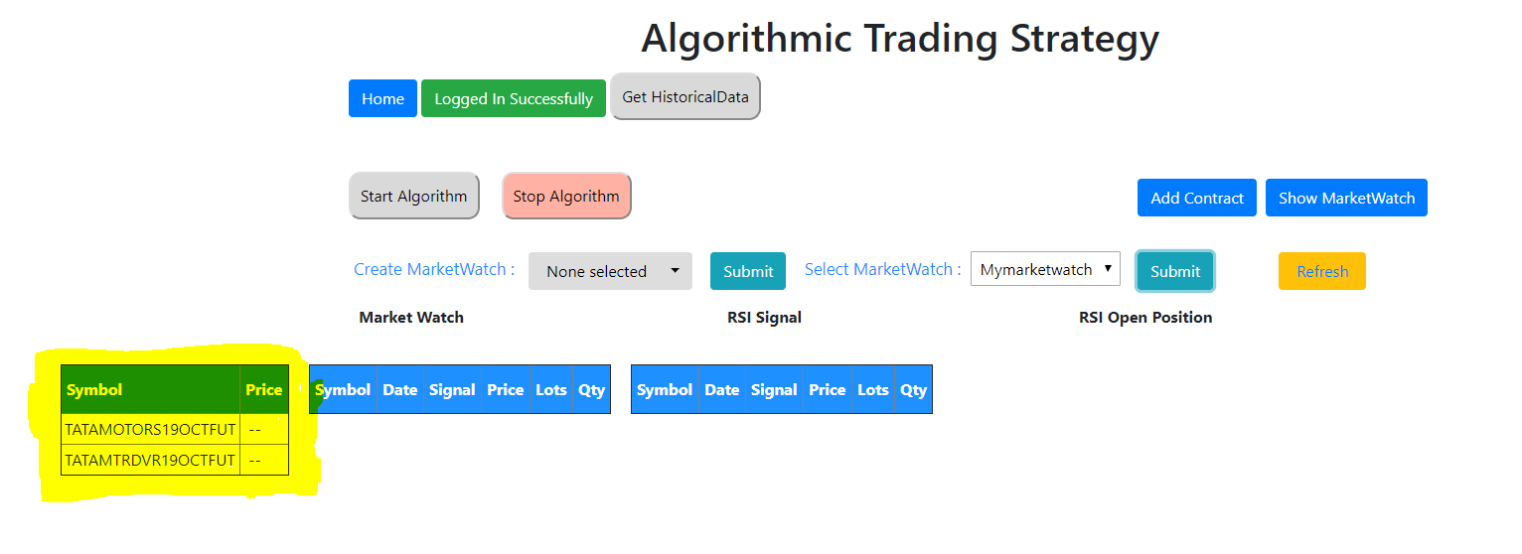

**STEP 8: If you wish to see your Market Watch with more details, click on “Show MarketWatch” button.**

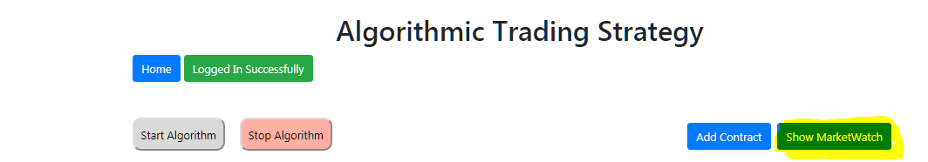

**After Clicking on “Show MarketWatch” button, you will get the below screen.**

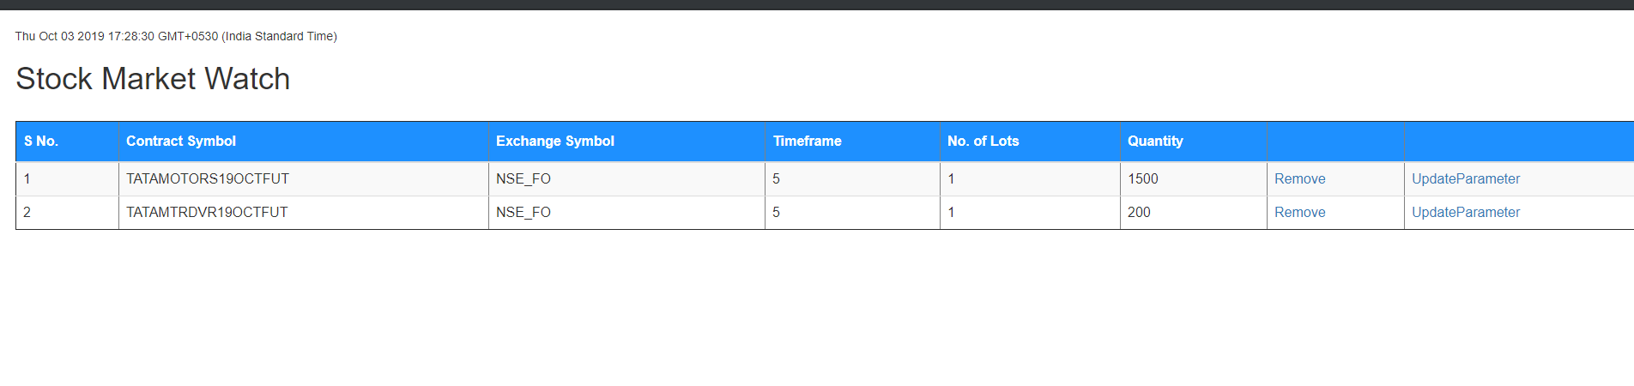

**STEP 9: Before Starting the Algorithm, we need to get the historical data of your marketwatch, It’s very simple just click on “Get Historical Data” button on the top.**

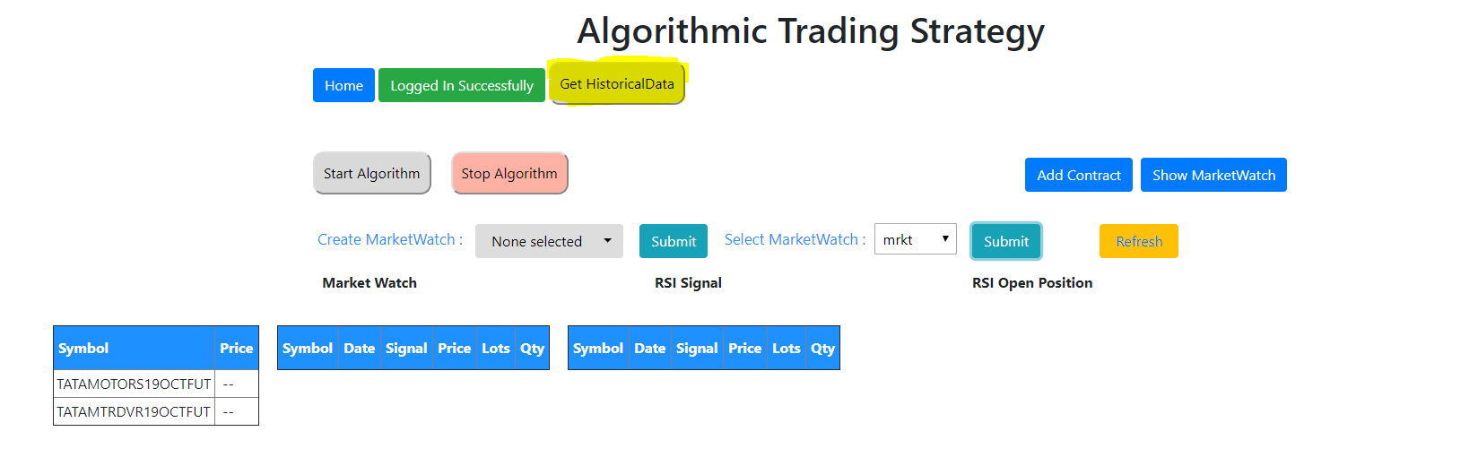

**STEP 10: Once we get the historical data, you will hear a “Beep” sound, That’s it. Now you are good to go. Just Click on “Start Algorithm” Button.**

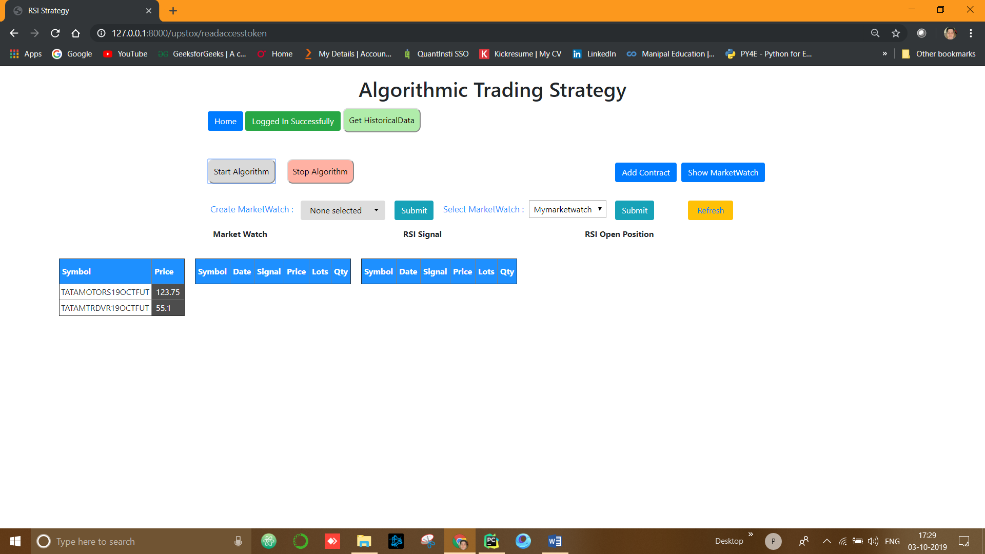

**The First leftmost table will show you the Stock Prices of stocks that are in your marketwatch.**

**The Middle table will show you the “Live Signals(LONG AND SHORT)”.**

**The Third table in the rightmost will show you the current open position with dynamic “PNL(Profit and Loss)”**

**STEP 11: Finally, to stop the Algorithm, click on “Stop Algorithm” button.**